MUSIC PLAYER APPLICATION
Mini Project Report
Abstract
The Music Player Application is a mobile application developed to provide uninterrupted music playback without requiring an internet connection. The application allows users to import songs from local storage, organize them into playlists, search songs, and customize the player interface. The project is developed using React, TypeScript and Capacitor technologies to deliver a modern and responsive user experience.

1. Introduction
Music applications have become an important part of daily life. Most existing applications depend on internet connectivity and consume mobile data. The Offline Music Player overcomes these limitations by providing seamless playback of locally stored audio files. The application offers a simple interface for managing music collections while ensuring smooth playback performance.

2. Problem Statement
Users often face difficulties accessing music in areas with poor network connectivity. Streaming applications also consume significant mobile data and battery power. Therefore, there is a need for an offline music player that can play songs stored on the device without internet dependency.

3. Objectives
• Provide offline audio playback.
• Import songs from device storage.
• Create and manage playlists.
• Search songs by title, artist, or album.
• Customize themes and playback settings.
• Deliver a user-friendly interface.

4. Technology Stack
Frontend: React with TypeScript
Mobile Framework: Capacitor
Build Tools: Bun / Vite
UI Components: Custom React Components
Storage: Local device storage
Programming Languages: TypeScript, JavaScript, CSS

5. System Methodology
The system imports audio files from the device and stores metadata locally. Users can browse songs in the library, create playlists, search tracks, and play music using the integrated player engine. Settings allow users to personalize themes, colors, and playback preferences.

6. Modules Description
Library Module: Imports and displays songs.
Playlist Module: Creates and manages playlists.
Search Module: Finds songs quickly.
Player Module: Controls playback, queue, lyrics, and equalizer.
Settings Module: Manages themes, colors, font size, and playback speed.

7. Results and Discussion
The application successfully supports offline playback with playlist management, search functionality, customizable settings, and a responsive user interface. The application works without internet connectivity and provides an enhanced listening experience.

8. Future Enhancements
Future improvements may include cloud synchronization, online streaming support, advanced equalizer features, recommendation systems, and lyrics synchronization.

9. Conclusion
The Offline Music Player application successfully meets the objective of providing reliable music playback without internet access. The project demonstrates the effective use of modern web technologies in developing mobile applications.

10. Application Screenshots

Library Screen

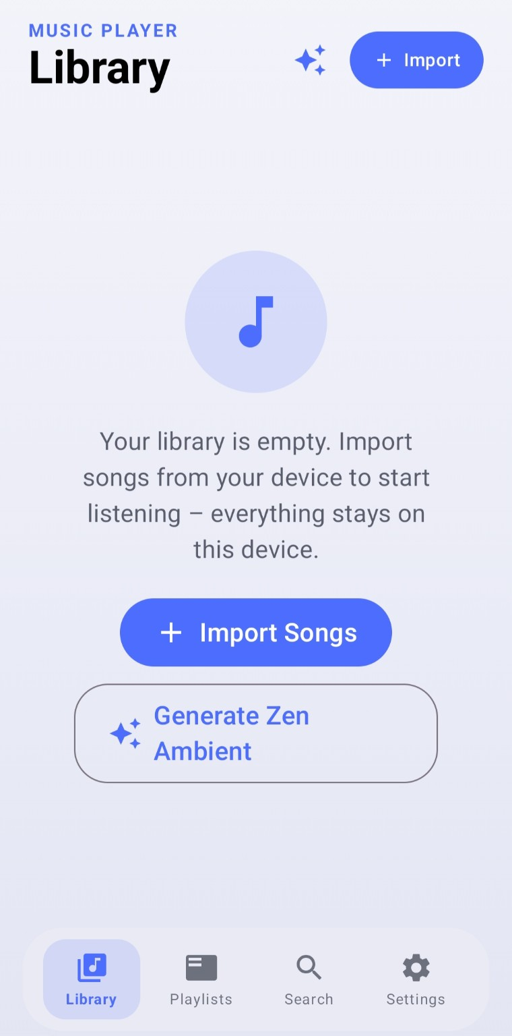

This screen allows users to import songs from local storage and manage their music library. When the user selects the Import Songs option, the application scans the device storage and retrieves supported audio files such as MP3, WAV, and AAC formats. The imported songs are stored locally, ensuring that the application functions without requiring an internet connection.
The library screen displays all available songs in an organized manner, allowing users to browse and select tracks easily. Since all music files remain on the user’s device, privacy and data security are maintained. The module also acts as the primary source for other features such as playlist creation, searching, and playback management.
Key Functions of the Library Module:
Import songs from local device storage.
Display all available songs in a structured format.
Store music information locally for offline access.
Provide quick access to songs for playback.
Serve as the main source for playlists and search operations.
Ensure uninterrupted music listening without internet connectivity.

Playlist Screen
Users can create and organize playlists for easy access to favorite songs.
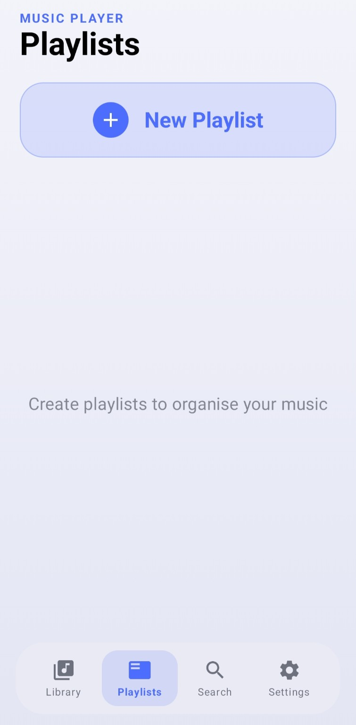

The Playlist module enables users to organize their music collection efficiently by creating customized playlists. This feature allows users to group songs based on their preferences, such as favorite tracks, mood, genre, artist, or special occasions.
Key Functions of the Playlist Module:
Create new playlists according to user preferences.
Add or remove songs from playlists.
Organize songs based on mood, genre, or favorites.
Provide quick access to frequently played songs.
Store playlists locally for offline usage.
Improve music management and user experience.
Advantages:
Reduces the time required to search for songs.
Enables personalized music organization.
Enhances the overall listening experience.
Supports uninterrupted offline music playback.

Search Screen
The search feature helps users quickly locate songs by title, The Search module is an important feature of the Offline Music Player application that enables users to quickly locate songs stored in the music library. As the number of songs in the library increases, manually browsing through all tracks becomes difficult and time-consuming. The Search feature overcomes this problem by allowing users to find songs instantly.
The Search screen provides a search bar where users can enter keywords such as the song title, artist name, or album name. As the user types, the application dynamically filters and displays matching results from the local music library. This improves accessibility and reduces the time required to locate specific songs.artist, or album.
Key Functions of the Search Module:
Search songs by title, artist, or album name.
Display search results instantly as the user types.
Provide quick access to selected songs.
Operate completely in offline mode.
Improve navigation within large music collections.

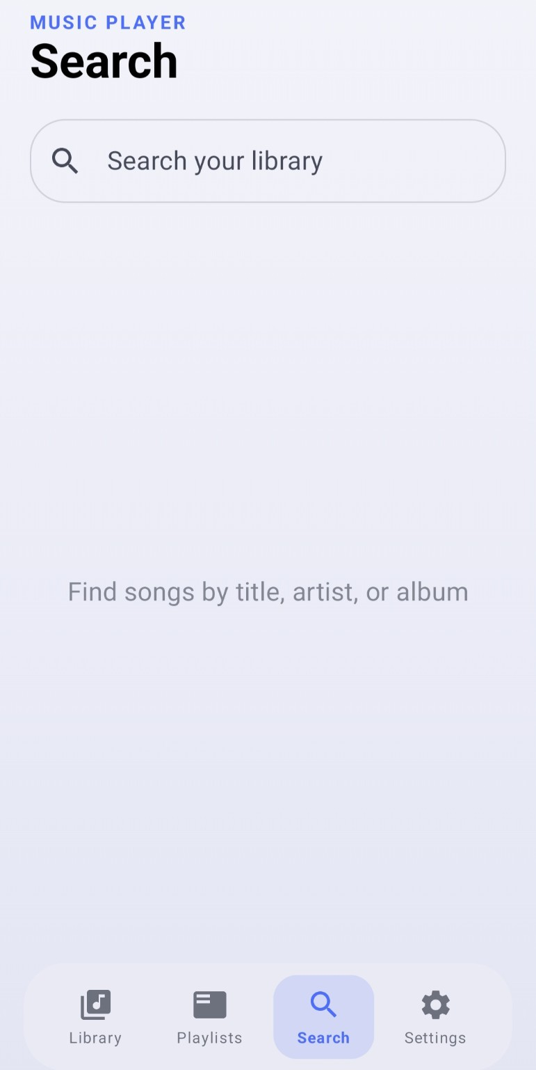
Settings Screen
Settings enable theme customization, accent color changes, font size adjustment, and playback configuration.
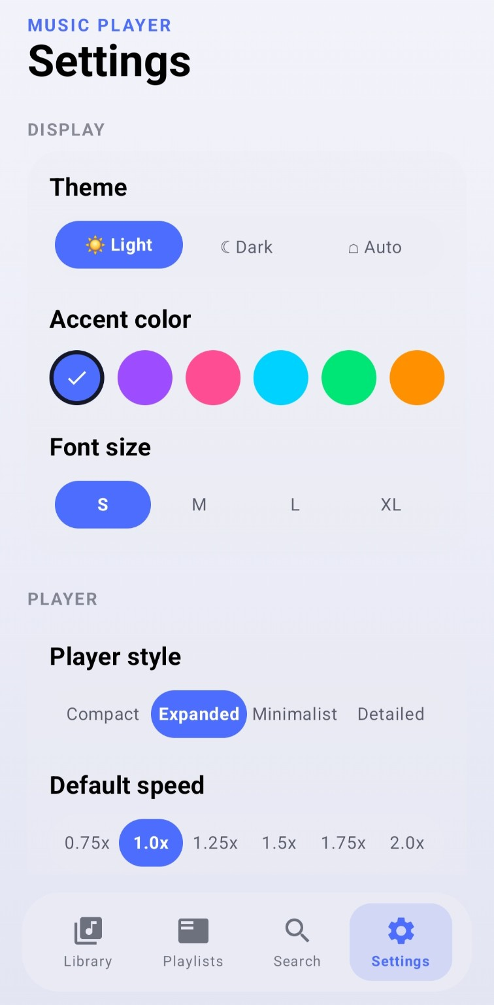
The Settings module allows users to personalize and customize the Offline Music Player according to their preferences. This module provides various options to modify the appearance and behavior of the application, thereby enhancing the overall user experience.
The Settings screen includes features such as theme selection, accent color customization, font size adjustment, player style configuration, and playback speed control. Users can choose between Light, Dark, or Auto themes to improve visual comfort based on their environment.
The application also provides multiple accent colors, enabling users to customize the interface appearance. Font size options help improve readability for different users, while various player styles allow users to select a music player layout that best suits their preferences.
Additionally, the playback speed feature enables users to adjust the speed of audio playback according to their listening requirements. All user preferences are stored locally on the device, ensuring that settings remain available even when the application is restarted.
Key Functions of the Settings Module:
Select application themes (Light, Dark, and Auto).
Customize accent colors for the user interface.
Adjust font size for better readability.
Choose different player styles.
Configure default playback speed settings.
Store user preferences locally.
Advantages:
Enhances the visual appearance of the application.
Improves accessibility and readability.
Provides a personalized listening experience.
Allows users to customize playback behavior.
Increases user satisfaction and convenience.

11. Advantages
- No internet required
- Low data consumption
- Easy playlist management
- Fast song search
- Customizable interface
- User friendly design

